Feature Image: "Discover 2025's Top Luxury Engagement Rings—Shop Now!"
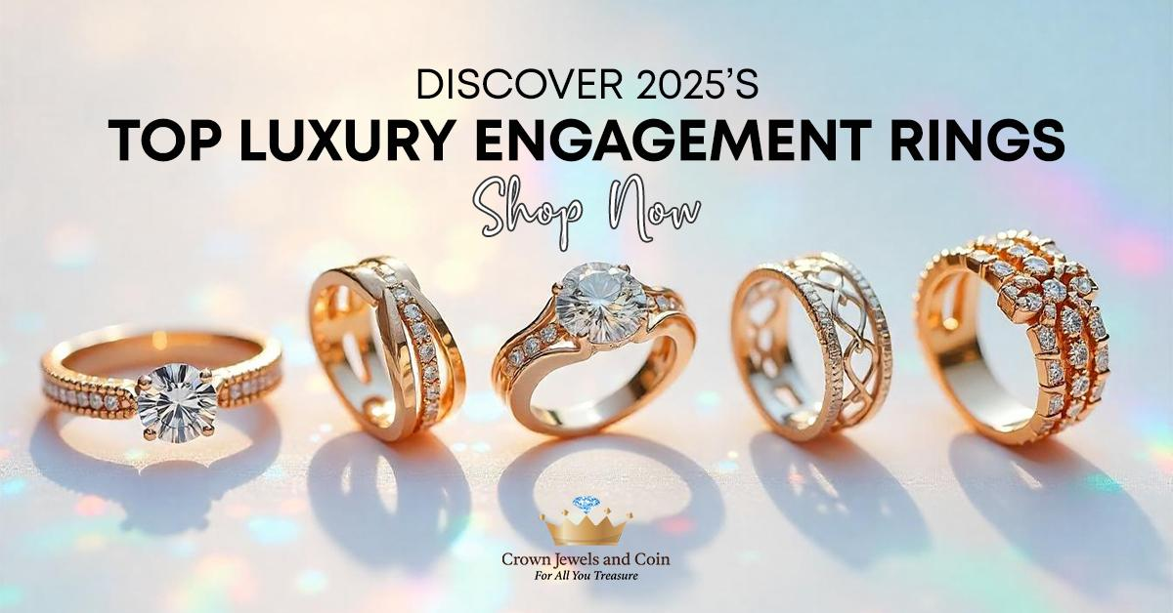

Title: Top Trends in Luxury Engagement Rings for 2025
Focus keyword: Luxury Engagement Rings
Secondary Keyword:
Unique Engagement Rings
Gold Engagement Rings
Diamond Engagement Rings

Internal links:
best jewelry store in Albuquerque: https://crownjewelsandcoin.com/
Engagement rings for women: https://crownjewelsandcoin.com/collections/engagement-rings

Meta Description:
Crown Jewels and Coin offers trendy luxury engagement ring for 2025. We create custom designs, eco-friendly rings, bold colors, and ensure ethical sourcing.

Top Trends in Luxury Engagement Rings for 2025 H1

Engagement rings are not just a token of love but also an emblem of devotion and a reflection of your character. Future predictions about the luxury engagement ring market during the period from 2025 indicate unexpected changes. Owning the ideal ring requires knowing upcoming trends because they will direct your selection process for diamond or gold rings. This blog examines multiple projected trends within the Luxury Engagement Ring field to assist your purchasing choice.

Customized Glamour to Steal the Show H2
One exciting tendency that characterizes modern trends of luxury engagement rings is personalization. Modern people strive for unique rings that can embody the personality of a man and a woman.
Today, customers who like creativity prefer custom Diamond Engagement Rings jewelers are now providing designs which can be modified to suit their personality. Additionally, now customers like to own rings with names, birthstones and other unique engravings. If you opt to hire the services of the best jewelry store in Albuquerque, you will have a specialist who will make sure that your dream piece is crafted with precision that highlights your love story.

Eco-Friendly Rings for a Greener Future H2
Now that the notion of sustainability is a concern that no industry can ignore, even the luxury pieces of jewelry are no longer immune to it. For the year 2025 and beyond, more rings are now being produced while considering the environment and the sources of the materials used.
As of now, jewelers are already embracing the concept by using metals that are recycled and certified diamonds. This saves the environment, and, to some extent, gives more significance to your ring. With such engagement rings, you can enjoy the look and feel of luxurious items, albeit being environmentally conscious.

Bold Colors and Experimental Designs H2
The future of the luxury engagement rings market is vibrant now. This was perhaps not true in the old days when only diamonds and gold were precious stones. Now jewelers are widely experimenting with the standard ring designs and incorporating bright and various colors into their creations.
In colorful and experimental designs, you can find options like sapphire, emerald and ruby because of their popularity. These colorful stones create dramatic statements that reflect the individual personality characteristics of their wearers.

Vintage-Inspired Styles for A Touch of Nostalgia H2
Trends from the past are returning to fashion and this applies to engagement rings as well. Focus on those rings that would get attracted by the charm that is associated with the Art Deco or Victorian styles of the rings. These rings form features of elaborate engravings and diverse shapes of these rings just like heart. Most of them, whether a gold band with filigree work or a diamond ring with a vintage cut gem, have a romantic and progressive look.

Ethical and Fair-Trade Jewelry for A Commitment to Fairness H2
There are certain ethical issues that surround the purchase of engagement rings. Today’s customers are more aware of fair-trade and demand for fairly source jewelry. Most of jewelry stores in Albuquerque now are keeping up to this trend by providing customers with rings of conflict-free diamonds as well as metals that are mined in the right manner. When you purchase our diamond rings for women, fair labour standards and ethical sourcing is guaranteed.

Technology and Innovation: A New Era of Ring Creation H2
Technology has shifted the course and path of human civilization, and the diamond industry is not left behind at all. The latest advancement in the field of technology such as 3D printing and laser cutting have brought exceptional designs into real life, what was just imaged a few years back. These developments make it possible to achieve finer touches and designs to suit the customer's preferences that are compatible with the client's expectations.

The Rise of Unique Engagement Rings in 2025 H3
Uniqueness is a new luxury. Now more than ever, engaged couples now wants extraordinary engagement rings and Albuquerque jewelers respond to this call. These rings come in asymmetrical patterns and are quite different from the regular styles offered.
One major features that give rise to unique engagement rings in 2025 is flared features of these rings, such as enamel or semi semi-precious stone, so that the ring will be unique and stand for something you truely stand. Let’s check out what you can expect from the great collection of engagement rings:

Gold Engagement Rings: Timeless and Versatile
Gold is still a popular choice for an engagement ring and its demand remains virtually unchanged up to the present time. From the precious yellow gold to rose gold, white gold, there is always an option that suits the taste of the client.

Diamond Engagement Rings: The Eternal Classic H3
Diamonds for years have been associated with class and love. However, today more varieties of styles are very trendy concerning diamond engagement rings and that is why people still prefer them for their charm and class. By the year 2025, new and innovative designs of the staple diamond ring will again be in trends that you must try once.

Engagement Rings for Women: Embracing Individuality H3
Nowadays, engagement rings for women are not limited in their choice to remain only in simple and traditional styles. The women rings of today reflect the spirit of uniqueness, and none can deny women the right to choose from the variety.

Conclusion H3
When moving further to the future of 2025, the luxurious engagement rings are expected to transform in various ways. From individual approach to environmentally friendly approach, these trends are versatile for every couple. If you have a patient and do research then you will be able to get a suitable ring that would depict your love.
For more options, you can also come to Crown Jewels and Coin that offers a fantastic deal of jewelry designs options. No matter if you go for the personalized engagement ring, a diamond ring, or a classic gold ring, your decision is symbolic of a love that will endure with time.

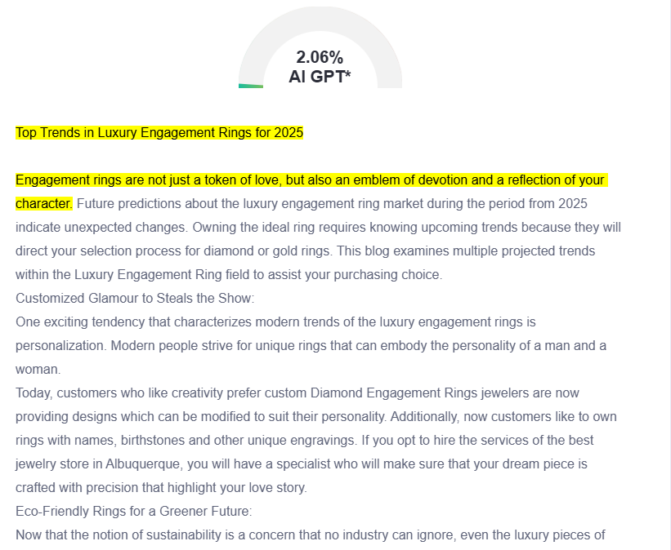

GMB

Discover the latest trends in luxury engagement rings at Crown Jewels and Coin in Albuquerque. We offer personalized rings that tell your unique love story with custom engravings, birthstones, and one-of-a-kind designs.The eco-friendly collection at our store presents certified diamonds embedded in recycled metals to cater to environmentally-minded couples. We offer a wider ring choice by experimenting with sapphires, emeralds and rubies because these stones provide powerful visual impact. Our collection includes vintage-style jewelry items featuring unique fabrics and elaborate engravings to attract those who love classic appeal. We guarantee the ethical sourcing of our diamonds which makes them conflict-free and our metals are sourced responsibly from the mines. The combination of 3D printing together with laser cutting technology allows us to develop revolutionary designs through flawless execution. Crown Jewels and Coin offers a broad selection of yellow gold rings together with rose, white gold and diamond rings with advanced settings to match your individual taste. At our store you will locate an engagement ring which demonstrates your love's forever while expressing your individual tastes and beliefs. Our expert jewelers will guide you through our extensive collection to find or create the perfect ring for your special moment.

